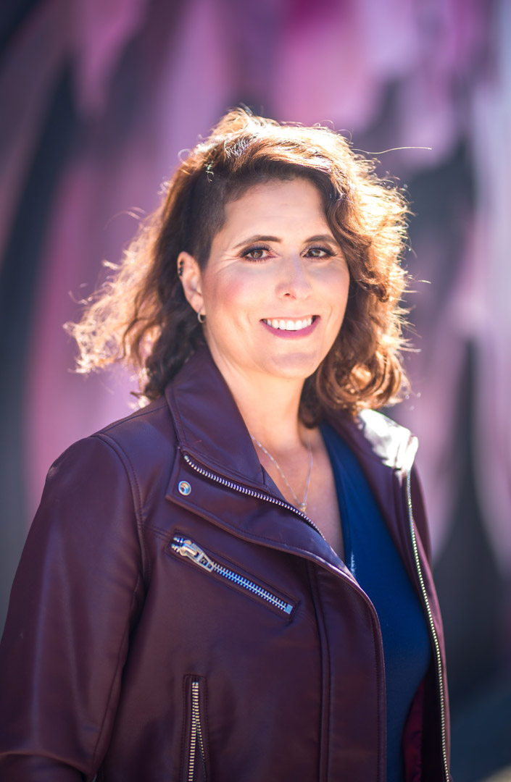

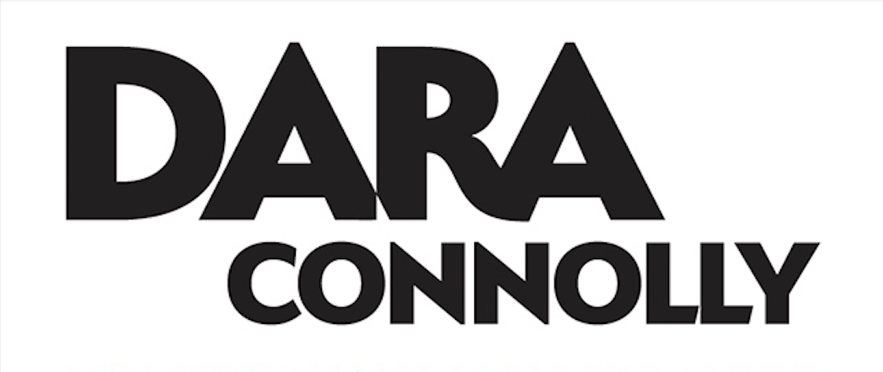
Dara Connolly Long Bio

Dara Connolly was the ultimate juxtaposition. A black-belt instructor who felt like a timid wallflower on the inside. Often, she felt frustrated when she was talked over at corporate meetings or not heard in social settings. To be more successful, Dara learned how to speak with impact and be more influential when speaking in front of an audience.

Today Dara is a TEDx Speaker, award-winning confidence coach, and 4x author–her latest book is called Flip Your Fear. She has trained thousands of individuals to speak with confidence to get their message heard – whether that’s to one or on a stage to many.

Her innovative coaching style and engaging presentations have trained everyone from entrepreneurs to sales teams, to actors, politicians, and professional athletes- when you know you to speak so others listen you can easily influence your audience.

Dara resides in the San Francisco Bay area. She enjoys international travel and hiking with her family and dog Bumper.

